**Below is a guide to assist in the setup of OneDrive on your old PC in preparation for your refreshed machine.**

Please see other relevant guides below:

* All guides
* How to ensure OneNote is backed up
* How to ensure Microsoft Edge bookmarks are backed up
* How to ensure Google Chrome bookmarks are backed up
* How to ensure Mozilla Firefox bookmarks are backed up
* First time logging into your refresh PC
* Installing software that you had on your old PC
* Adding printers

Please ensure that any files of importance (Including anything located in your mapped U drive U:\) are moved to the following three folders:

* Desktop
* Documents
* Pictures

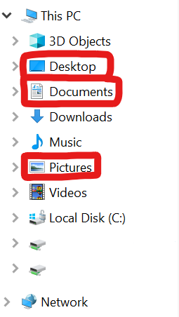

Left click the OneDrive icon on your taskbar (bottom right on your main desktop display)



Left click the Help & Settings cog icon.

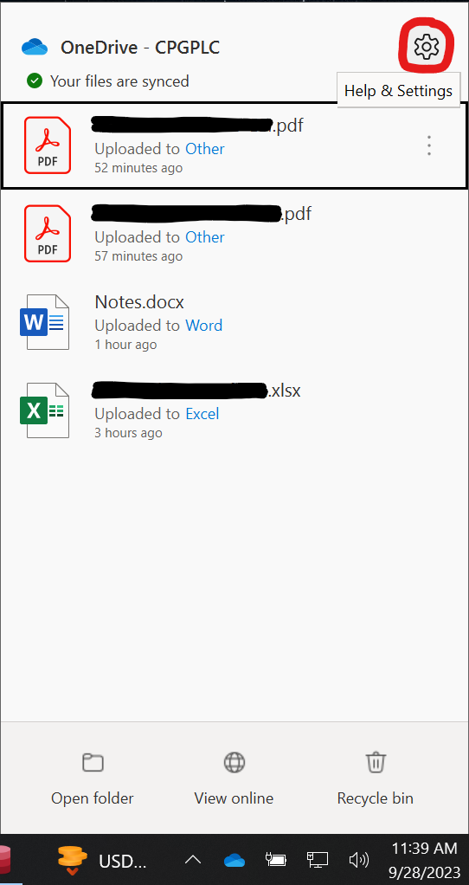

Left click Settings.

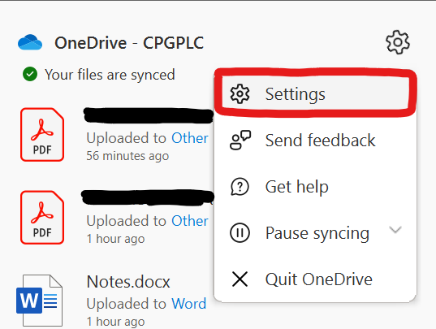

Left click Sync and backup

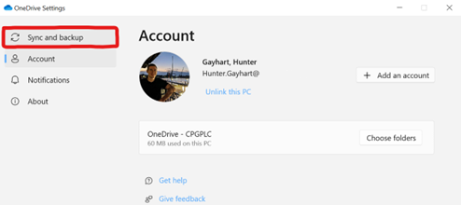

Left click Manage backup

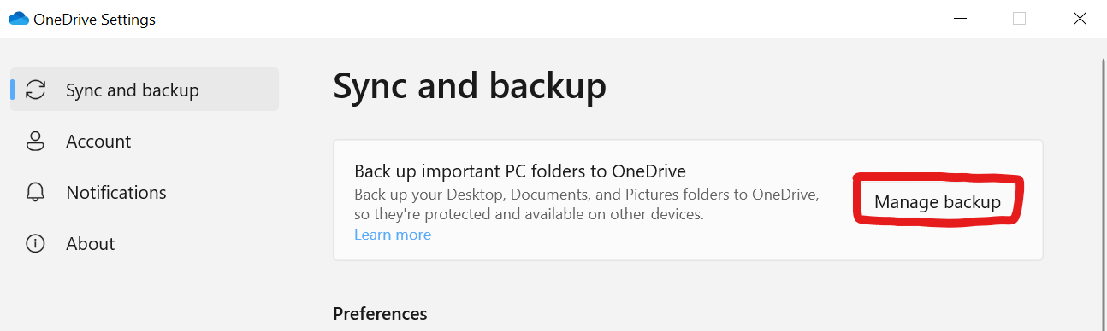

Left click all 3 radio sliders, changing their color from gray to blue

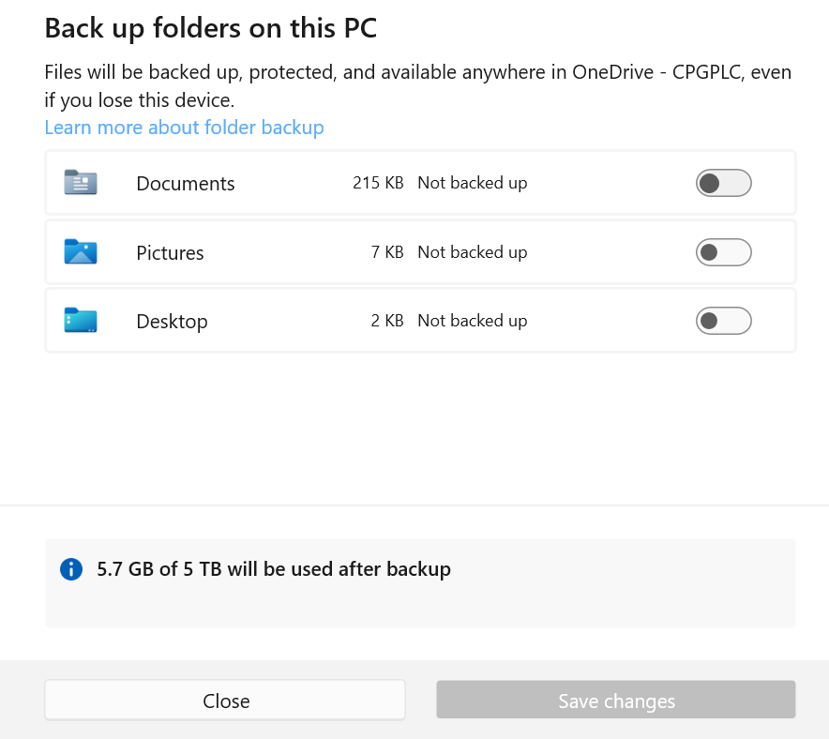

Select save changes.

Your files are now uploading to OneDrive.

Verify that these files are uploaded by logging into the [OneDrive Live website](https://onedrive.live.com/) using your Compass email.